Quiz

Top of Form

**Question 1**(1 point)

*Saved*

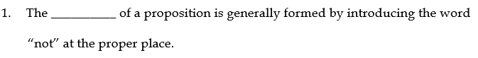

Question 1 options:

|  |  |
| --- | --- |
|  |  |
|  |  |
|  |  |
|  |  |

**Question 2**(1 point)

*Saved*



Question 2 options:

|  |  |
| --- | --- |
|  |  |
|  |  |
|  |  |
|  |  |

**Question 3**(1 point)

*Saved*

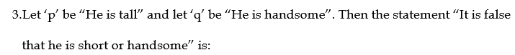

Question 3 options:

|  |  |
| --- | --- |
|  |  |
|  |  |
|  |  |
|  |  |

**Question 4**(1 point)

*Saved*



Question 4 options:

|  |  |
| --- | --- |
|  |  |
|  |  |
|  |  |
|  |  |

**Question 5**(1 point)

*Saved*



Question 5 options:

|  |  |
| --- | --- |
|  |  |
|  |  |
|  |  |
|  |  |

**Question 6**(1 point)

*Saved*



Question 6 options:

|  |  |
| --- | --- |
|  |  |
|  |  |
|  |  |
|  |  |

**Question 7**(1 point)

*Saved*



Question 7 options:

|  |  |
| --- | --- |
|  |  |
|  |  |
|  |  |
|  |  |

**Question 8**(1 point)

*Saved*

A declarative sentence which is true or false but not both is called

Question 8 options:

|  |  |
| --- | --- |
|  | a Proposition |
|  | a Tautology |
|  | a contradiction |
|  | contingency |

**Question 9**(1 point)

*Saved*



Question 9 options:

|  |  |
| --- | --- |
|  |  |
|  |  |
|  |  |
|  |  |

**Question 10**(1 point)

*Saved*

A statement is also known as

Question 10 options:

|  |  |
| --- | --- |
|  | a hypothesis |
|  | an assumption |
|  | a Proposition |
|  | a conclusion |

Submit Quiz*10 of 10 questions saved*

Bottom of Form